**Practical - 02**

**Title: - Program to simulate traffic between two nodes**

**Aim: -** To simulate traffic between two nodes

**Lab Objectives: -**

To get familiarize with a Network Simulation Tool

**Description: -**

A network is two or more devices connected through links. A link is a communications pathway that transfers data from one device to another.

There are two possible types of connections:

1. point-to-point
2. multipoint.

**Point-to-point connection**

Point-to-point connection provides a dedicated link between two devices.

The entire capacity of the link is reserved for transmission between those two devices.

Use an actual length of wire or cable to connect the two ends, but other options, such as microwave or satellite links, are also possible.

For example, When you change television channels by infrared remote control, you are establishing a point-to-point connection between the remote control and the television's control system.

**Multipoint**

A multipoint (also called multidrop) connection is one in which more than two specific devices share a single link

In a multipoint environment, the capacity of the channel is shared, either spatially or temporally.

If several devices can use the link simultaneously, it is a spatially shared connection.

If users must take turns, it is a timeshared connection.

**Exercises**

1. Write a program to implement the given point to point topology and simulate traffic between two nodes.



10.0.0.1

10.0.0.2

**Code:**

**/*-*- Mode:C++; c-file-style:"gnu"; indent-tabs-mode:nil; -*-*/**

**// add required header files**

#include "ns3/core-module.h"

#include "ns3/network-module.h"

#include "ns3/internet-module.h"

#include "ns3/point-to-point-module.h"

#include "ns3/applications-module.h"

#include "ns3/netanim-module.h"

#include "ns3/csma-module.h"

#include "ns3/ipv4-global-routing-helper.h"

**// Adding namespace declaration**

using namespace ns3;

**//Define log component where log msgs will be saved**

NS_LOG_COMPONENT_DEFINE("p2pExample");

**// Main function**

int main(int argc, char *argv[]){

**// read the command line arguments**

CommandLine cmd(__FILE__);

**// Process the command line arguments**

cmd.Parse(argc, argv);

**// Set time Resolution to 1 nano second**

Time::SetResolution(Time::NS);

**// Logging**

LogComponentEnable("UdpEchoClientApplication",LOG_LEVEL_INFO);

LogComponentEnable("UdpEchoServerApplication",LOG_LEVEL_INFO);

**// Create NodeContainer object to store our nodes**

NodeContainer nodes;

**// Create 2 nodes**

nodes.Create(2);

**// create object of the point-to-point helper object class to configure net device and the channels**

PointToPointHelper pointToPoint;

**// Configure the net Device**

pointToPoint.SetDeviceAttribute("DataRate", StringValue("5Mbps")); **// Set Data Rate**

**// Configure the Channel**

pointToPoint.SetChannelAttribute("Delay", StringValue("2ms")); **// Set Delay Attribute**

**// Install net devices on nodes**

NetDeviceContainer devices;

devices=pointToPoint.Install(nodes);

**// install netdevices on node and connect with the Channels**

**// Configure and Install protocol suits on nodes**

InternetStackHelper stack;

stack.Install (nodes);

**// configure network IP address and subnet mask for network**

Ipv4AddressHelper address;

**// set data**

address.SetBase("10.0.0.0","255.0.0.0");

**// Assign IP addresses to the interfaces of netDevices**

Ipv4InterfaceContainer interfaces = address.Assign(devices);

**// Configure our Applications**

**// Configure UDPEchoServerApplication**

UdpEchoServerHelper echoServer(9); **// Setting port number of server application**

**// Application Container create object to store server application and install on node(1)**

ApplicationContainer serverApp = echoServer.Install(nodes.Get(1)); **// indexed 1 server**

**// Configure start and stop time of server Application**

serverApp.Start(Seconds(1.0)); **// server app should start first**

serverApp.Stop(Seconds(10.0)); **// server app should stop**

**// Configure UdpEchoClientApplication**

UdpEchoClientHelper echoClient(interfaces.GetAddress(1),9);

**// Configure the attribute of client Application**

echoClient.SetAttribute("MaxPackets", UintegerValue (1));

echoClient.SetAttribute("Interval", TimeValue (Seconds(1.0)));

echoClient.SetAttribute("PacketSize", UintegerValue (1024));

**// Install Client Application on Node 0**

ApplicationContainer clientApp = echoClient.Install(nodes.Get(0));

**// Enables Routing between two networks 10.0.0.0 and 20.0.0.0**

Ipv4GlobalRoutingHelper::PopulateRoutingTables();

**// for Running the code**

AnimationInterface anim("p2pAniExcer.xml");

anim.SetConstantPosition(nodes.Get(0),20.0,30.0);

anim.SetConstantPosition(nodes.Get(1),40.0,30.0);

**// Configure Start and Stop Time**

clientApp.Start(Seconds(2.0));

clientApp.Stop(Seconds(10.0));

**// Simulation on Run and start**

Simulator::Run();

**// Destory this Resourses**

Simulator::Destroy();

return 0;

}

**Output**

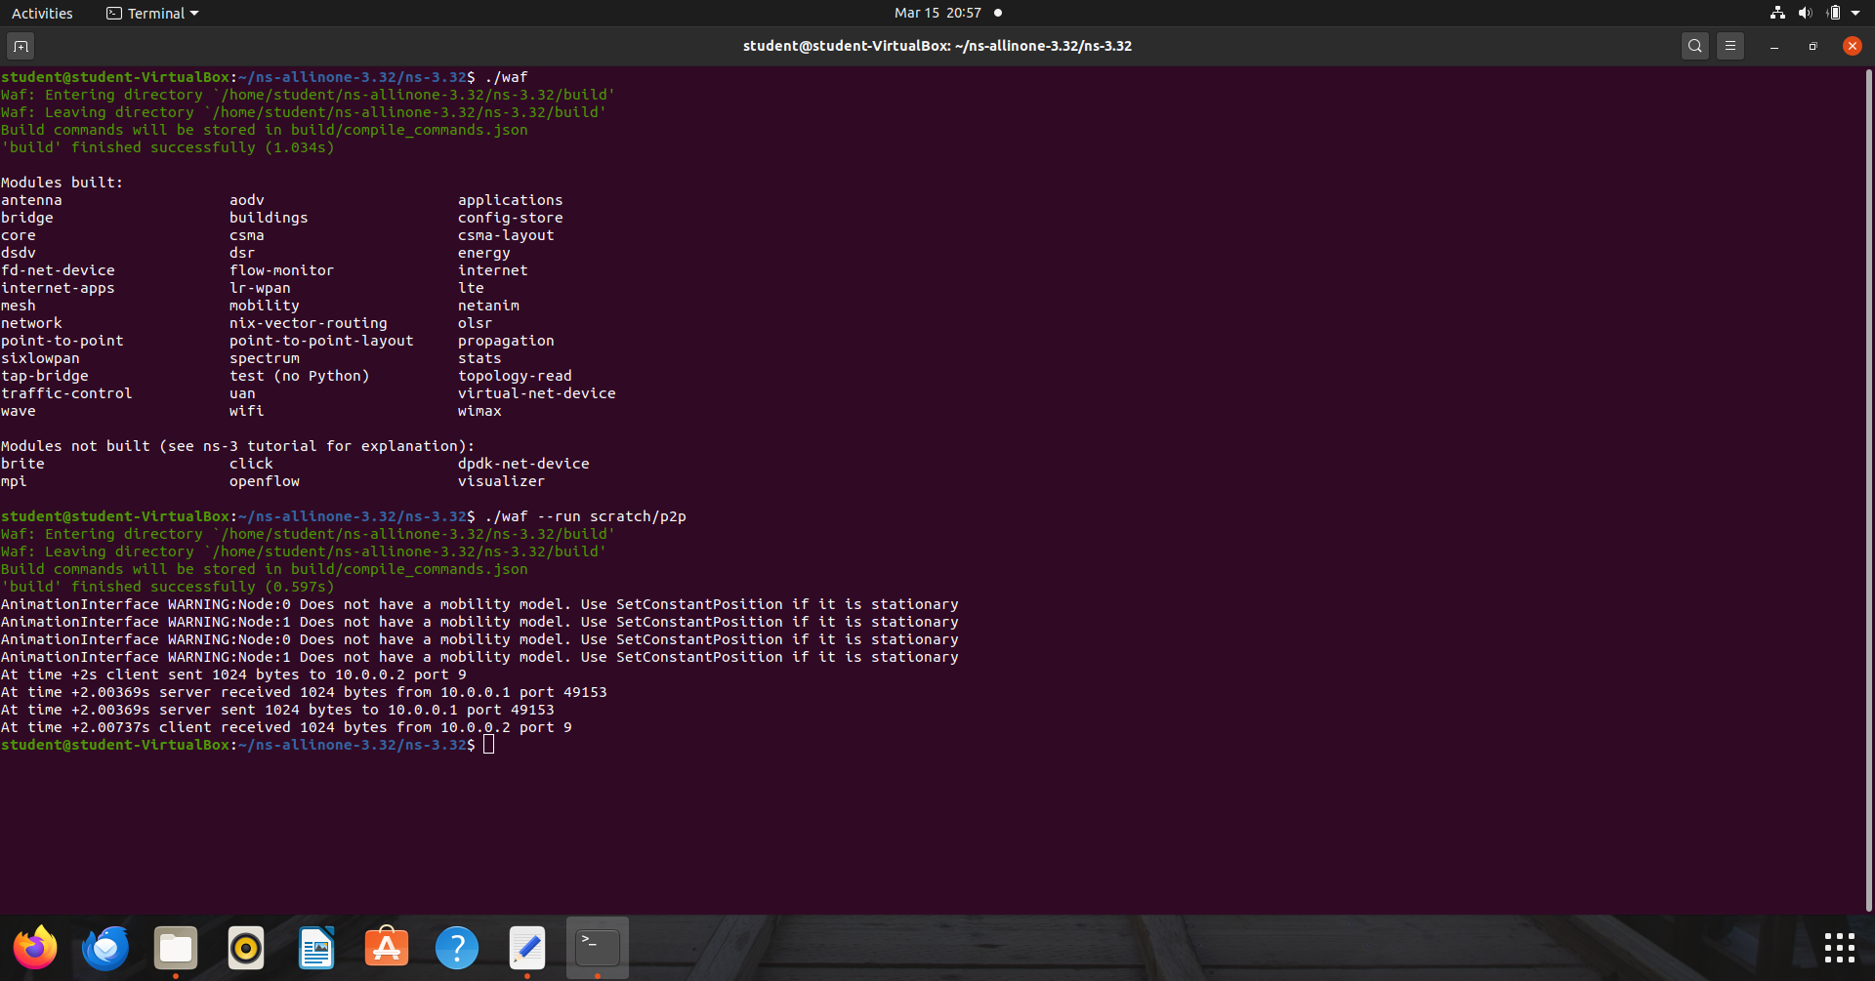

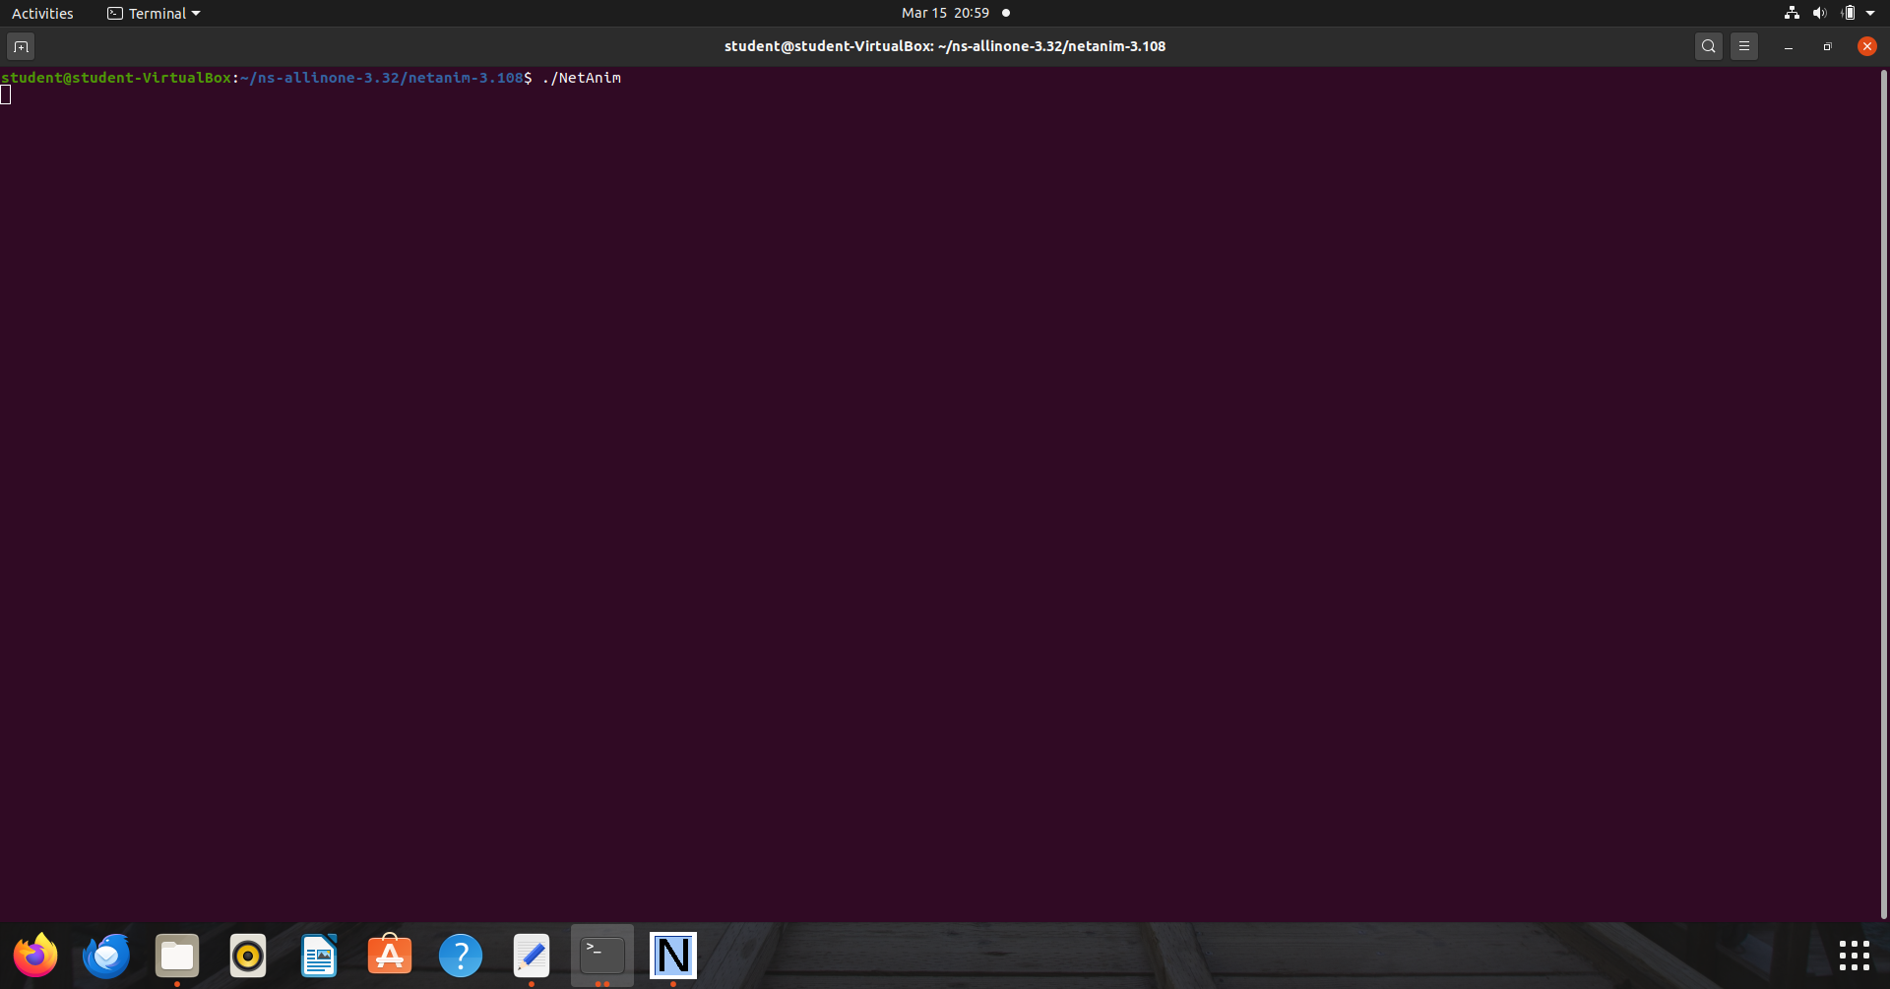

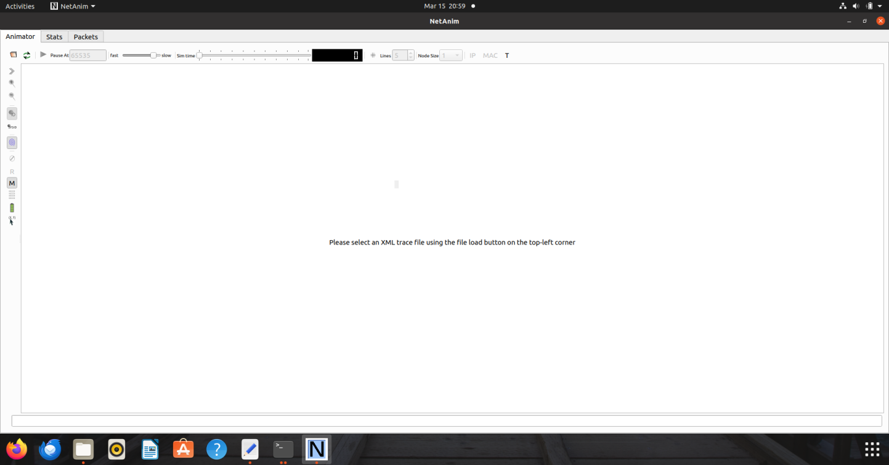

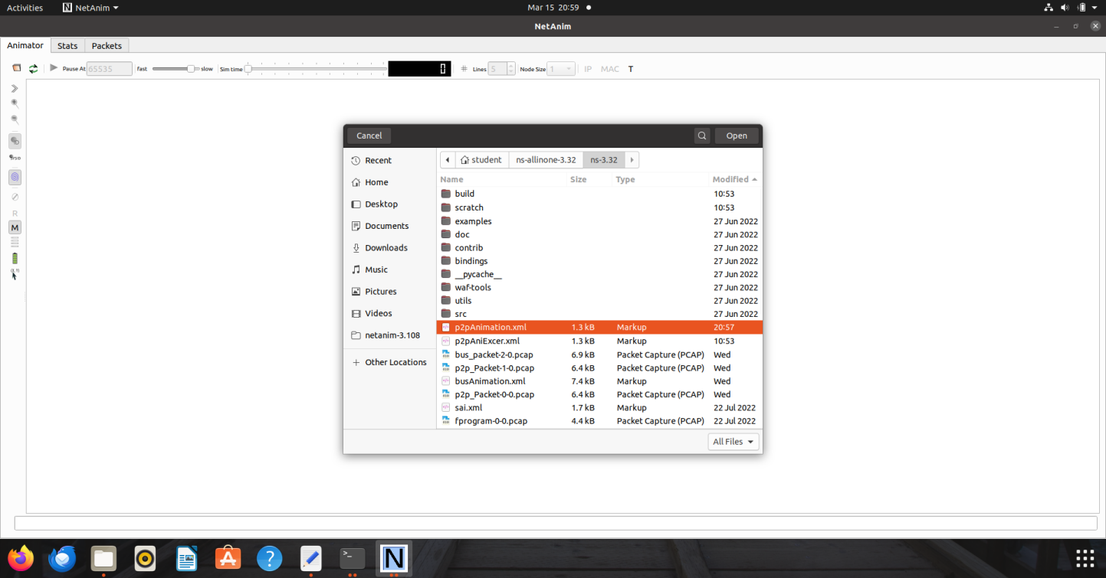

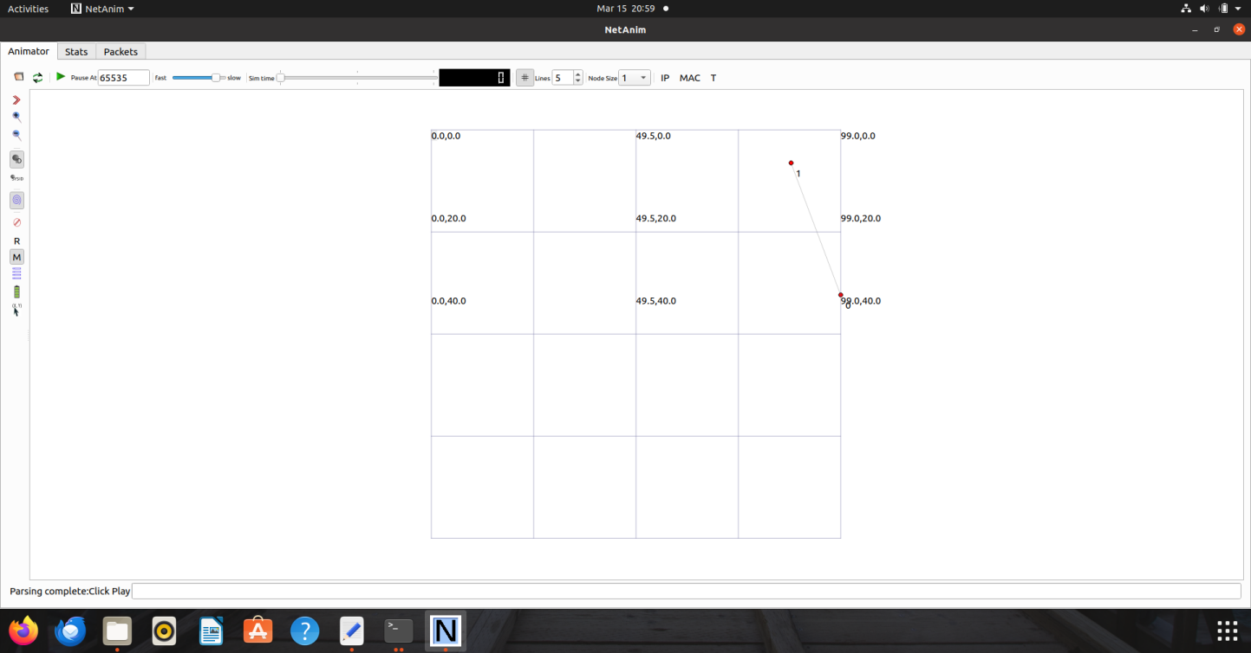

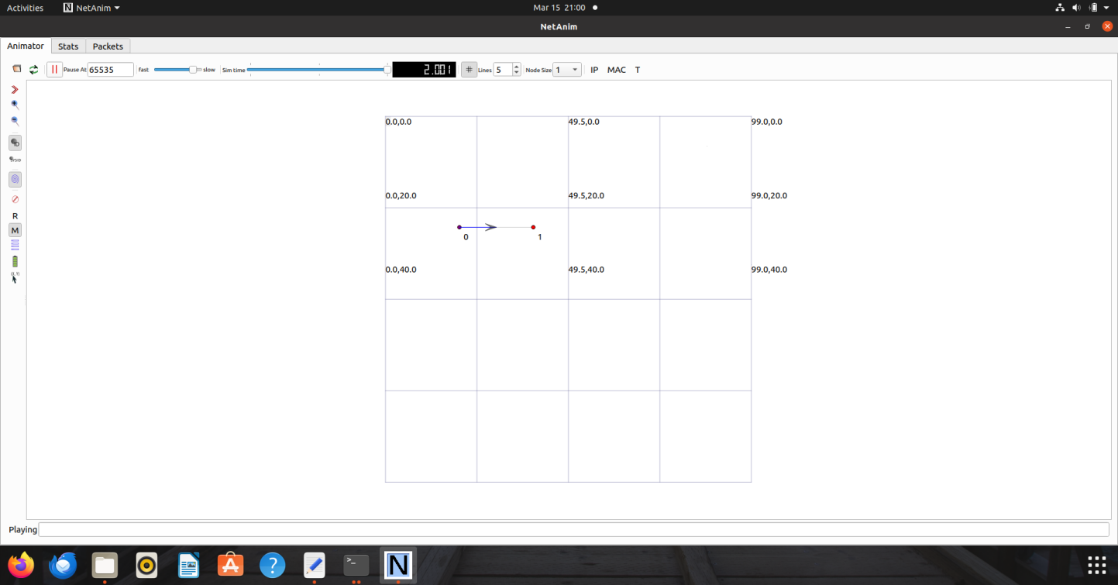

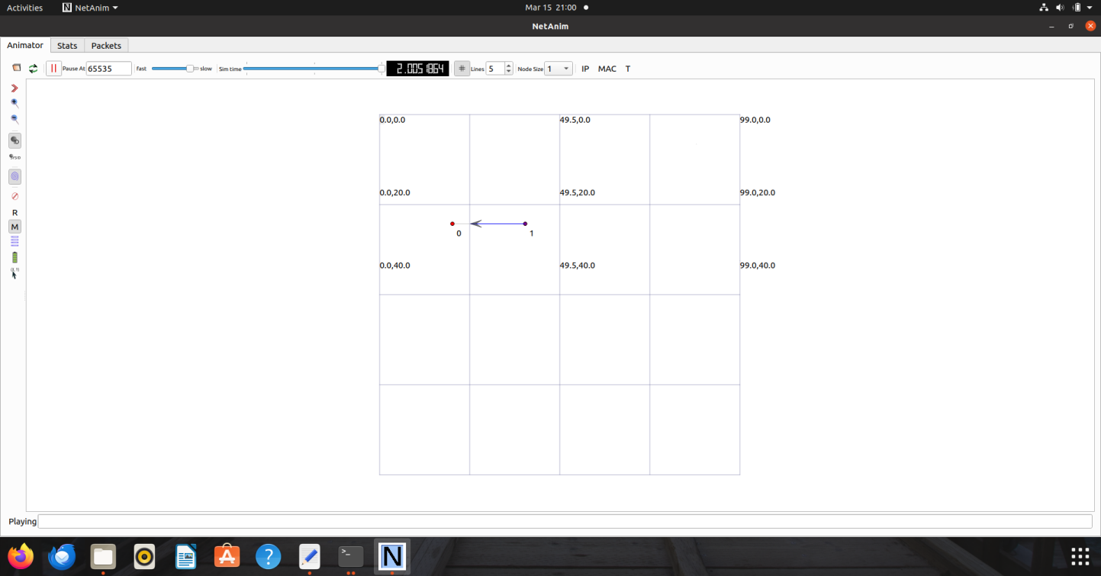

**Conclusion:** Implemented point to point topology and simulate traffic between two nodes

**After performing this Practical/lab, students are expected to answer the following questions.**

1. What is the Boilerplate?
2. What are the seven levels of log messages?
3. Explain the following classes and methods in those classes which are used in your script.
   1. NodeContainer
   2. PointToPointHelper
   3. NetDeviceContainer
   4. InternetStackHelper
   5. Ipv4AddressHelper
   6. Ipv4InterfaceContainer

Reference

<https://www.nsnam.org/docs/release/3.15/doxygen/classns3_1_1_node_container.html#details>

<https://www.nsnam.org/docs/release/3.15/doxygen/classns3_1_1_point_to_point_helper.html#details>

<https://www.nsnam.org/docs/release/3.15/doxygen/classns3_1_1_net_device_container.html>

<https://www.nsnam.org/docs/release/3.15/doxygen/classns3_1_1_internet_stack_helper.html>

<https://www.nsnam.org/docs/release/3.15/doxygen/classns3_1_1_ipv4_address_helper.html>

<https://www.nsnam.org/docs/release/3.15/doxygen/classns3_1_1_ipv4_interface_container.html>

<https://www.nsnam.org/docs/tutorial/html/conceptual-overview.html>

<https://www.nsnam.org/docs/release/3.7/tutorial/tutorial_21.html>